

**Board RCU 7A 2 CH**

**(Arduino Nano/Uno Compatible)**

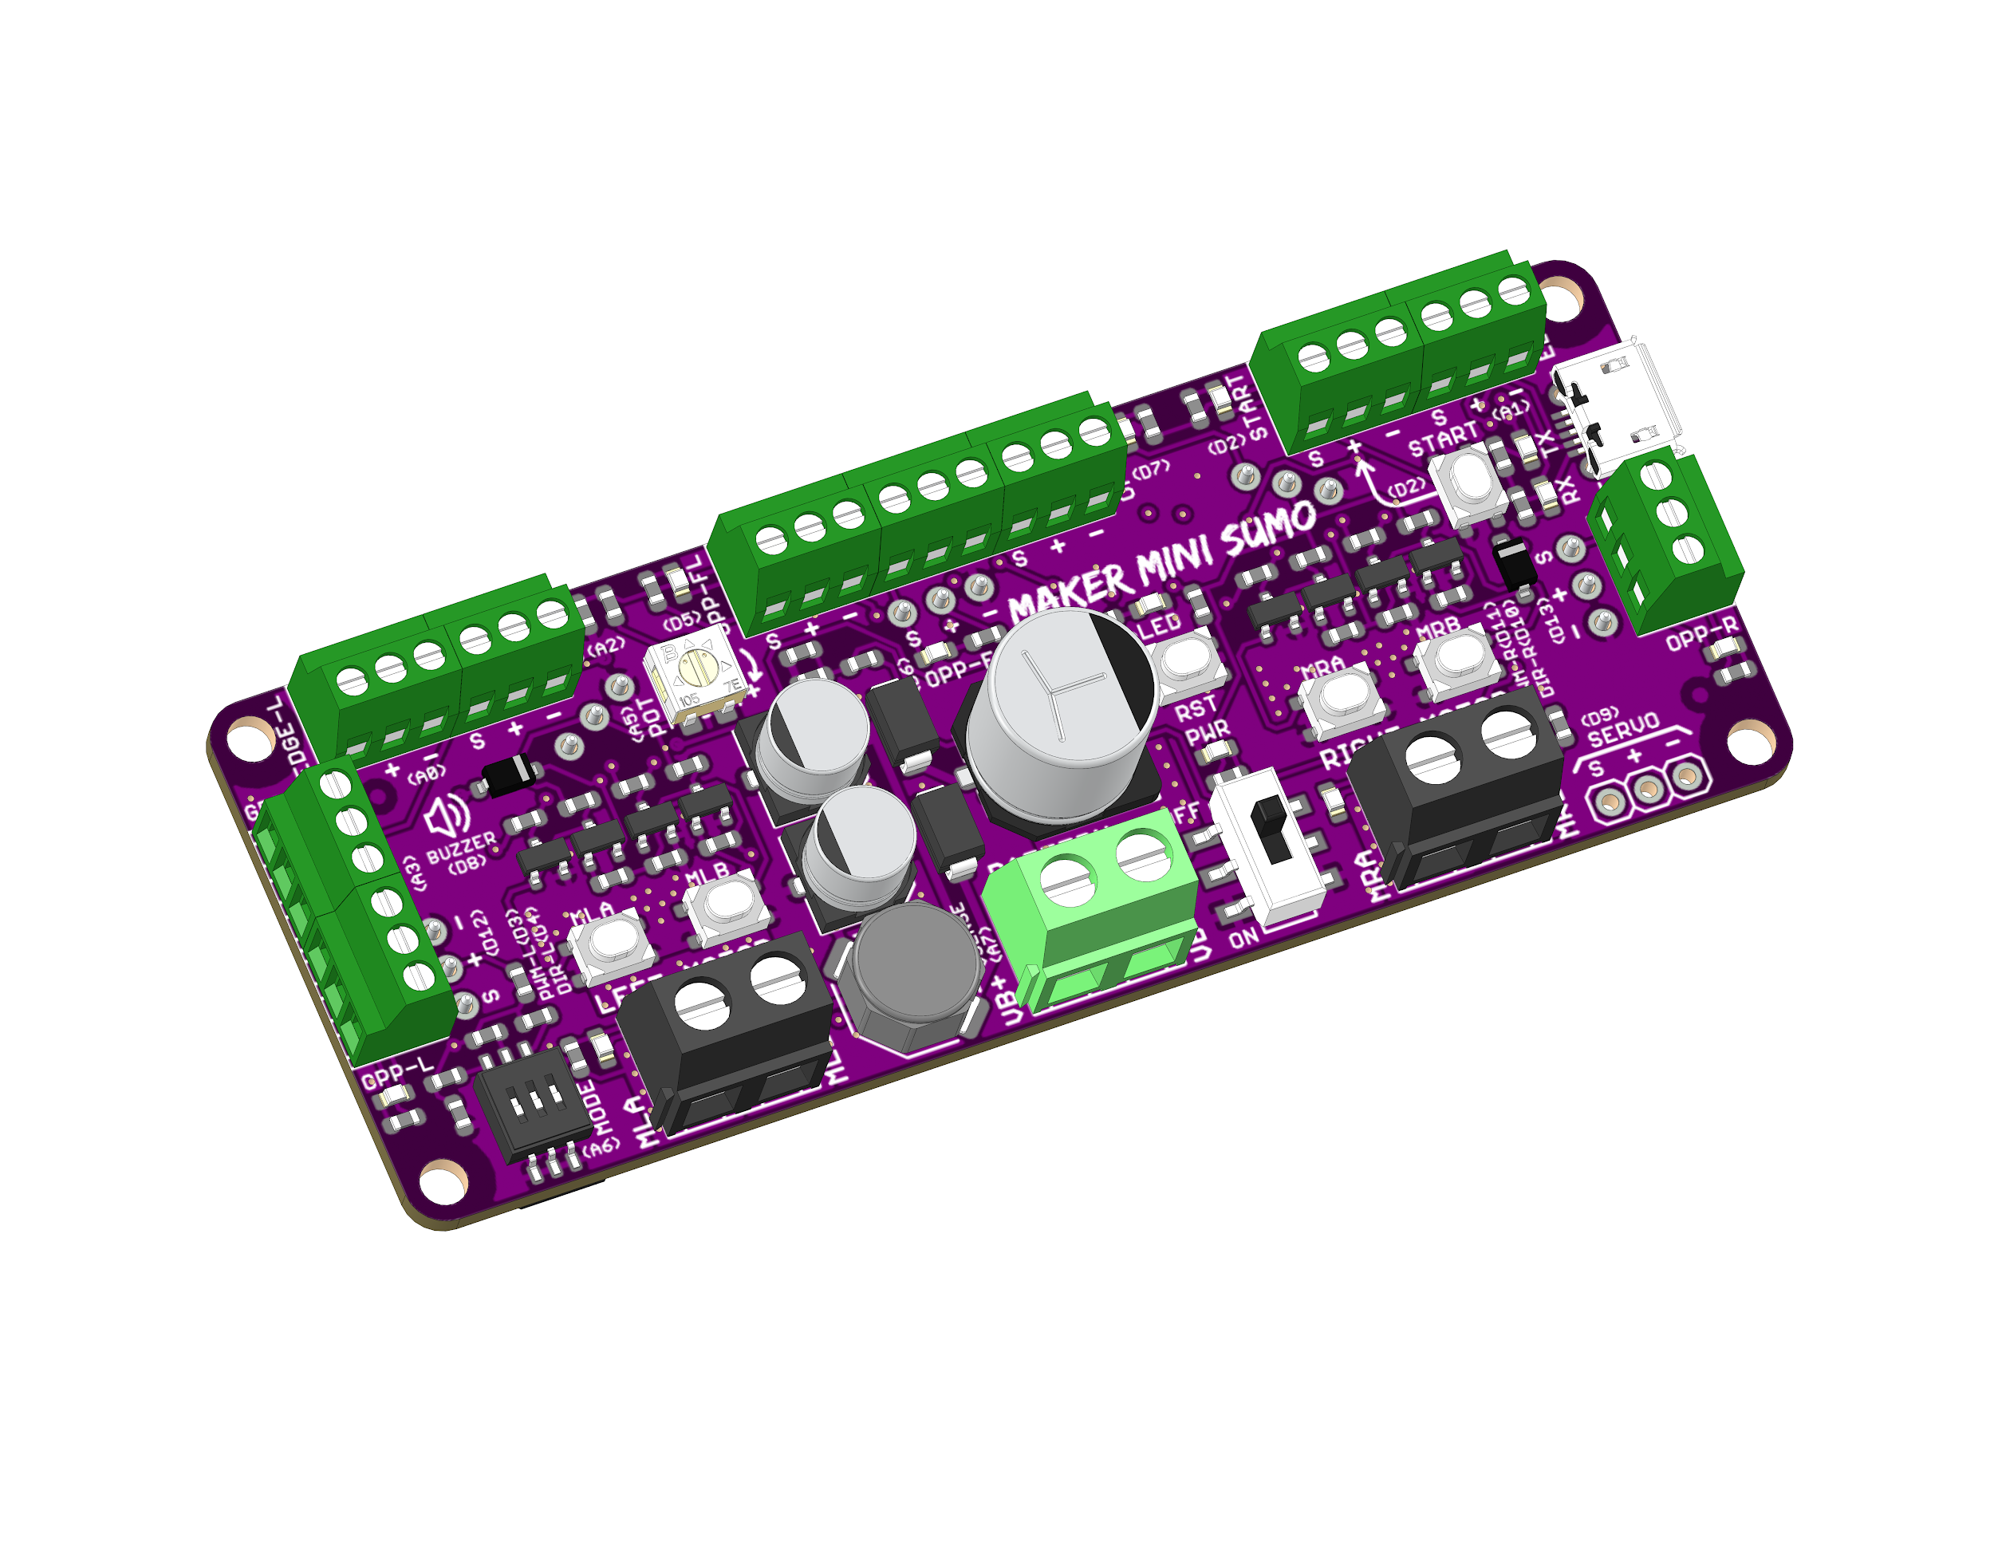

Datasheet

Rev 1.0

January 2025

|  |
| --- |
| Information in this publication regarding device applications and the like is intended through suggestion only and may be superseded by updates. It is your responsibility to ensure that your application meets with your specifications. No representation or warranty is given, and no liability is assumed by Mycest Solution Incorporated with respect to the accuracy or use of such information or infringement of patents or other intellectual property rights arising from such use or otherwise. Use of Mycest Solutions’s products as critical components in life support system is not authorized except with express written approval by Mycest Solutions. No licenses are conveyed, implicitly or otherwise, under any intellectual property rights. |

# 1. FEATURES

* Arduino Nano/Uno Compatible (Powered by ATMEGA328P).
* Vin: 5V - 12V
* Reverse polarity protection on Vin.
* Switching regulator for +5V reduce heat and increase efficiency.
* Motor: 3A continuous, 6A peak
* Test buttons and status LED for motors.
* 1 x Start Module Input (Digital), with LED and onboard start button.
* 1 x Onboard Potentiometer.
* 1 x Mode Selection DIP Switch (3 Ways).
* Converts higher voltage down to 5v for microcontroller operation.
* 4 x Extra Digital pin and Analog pin on board.

# 2. BOARD LAYOUT & FUNCTION

*Figure 1: RCU 7A 2CH Board Functions (Top)*

|  |  |
| --- | --- |
| **Function** | **Description** |
| **Battery Terminal** | Connect to battery.   * VIN+ : Positive * VIN- : Negative/Ground |
| **On/Off Switch** | Turn on/off the power to the board. |
| **Motor Terminals** | Connect to motors.  Motor direction is dependent on the polarity. |
| **Motor Status LEDs** | Turn on when the motor is running.   * MLA / MRA : Forward* * MLB / MRB : Backward* |
| **Analog Pin & Digital Pin** | Can be used as a digital input/output or analog input.   * S : Digital Input/Output or Analog Input Signal. * V : DC +5V Output. * G : Ground. |
| **Dual-15 pin Arduino Nano** | Connect Arduino Nano on board |
| **Potentiometer** | Connected internally to analog input.  Can be used to fine tune the robot speed, sensor threshold, etc... |
| **Mode Selection**  **DIP Switch** | 3-Ways DIP switch provides up to 8 configurations.  Can be used to select different tactic/mode for competition. |
| **Calibrate Switch** | Use to calibrate to establish movement |
| **Motor Calibrate Switch** | Use to calibrate Motor forward and backward, right and left. |

*Table 1: RCU 7A 2CH Board Functions (Top)*

* *Actual motor direction is dependent on the motor connection.*

*Swapping the connection (MxA & MxB) will reverse the direction.*

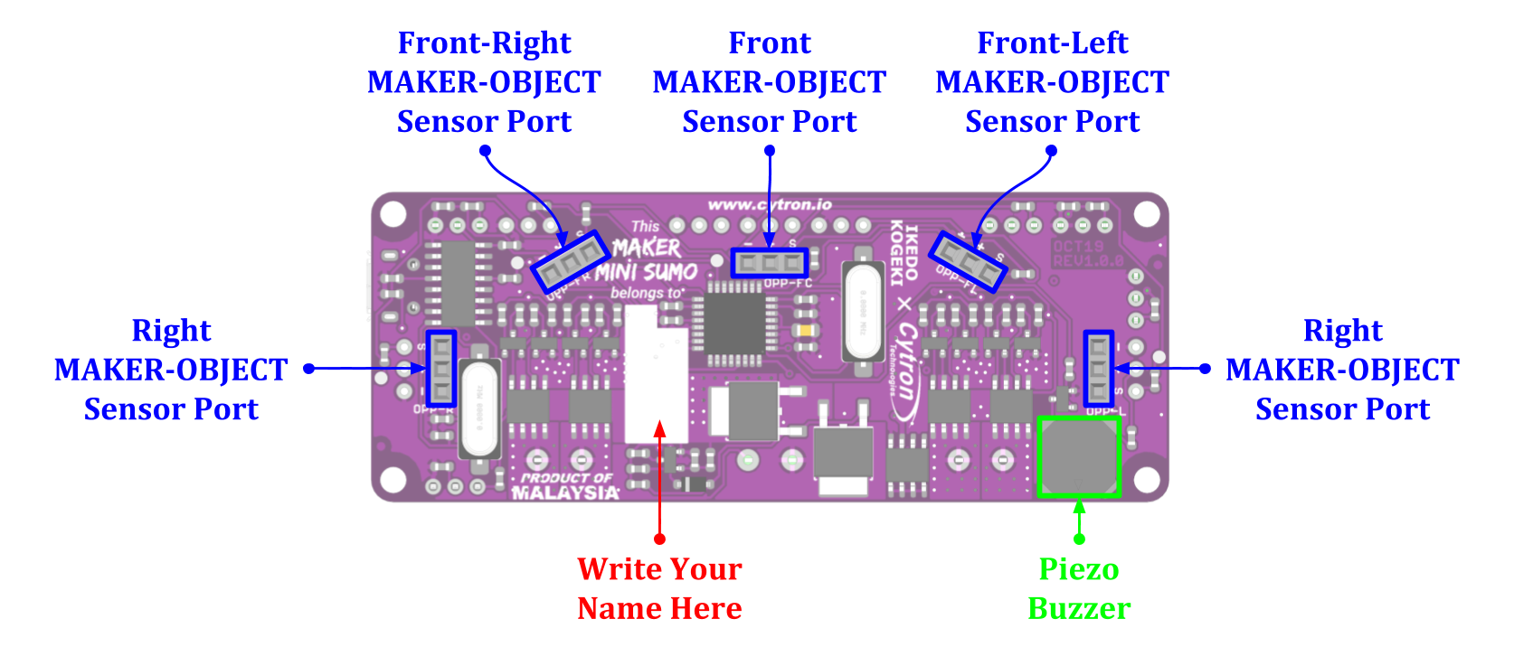

*Figure 2: RCU 7A 2CH Board (Bottom)*

|  |  |  |  |  |
| --- | --- | --- | --- | --- |
| **PWM-L/PWM-R** | **DIR-L/DIR-R** | **MLA/MRA** | **MLB/MRB** | **Motor** |
| **Low** | **X (Don’t Care)** | Low | Low | Brake |
| **High** | **Low** | High | Low | Forward* |
| **High** | **High** | Low | High | Backward* |

*Table 3: Input Truth Table*

|  |  |  |  |
| --- | --- | --- | --- |
| DIP Switch Output | | | Sensor Value |
| 0 | 0 | 0 | 0 |
| 0 | 0 | 1 | 839-841 |
| 0 | 1 | 0 | 930-932 |
| 0 | 1 | 1 | 957-959 |
| 1 | 0 | 0 | 977-979 |
| 1 | 0 | 1 | 985-987 |
| 1 | 1 | 0 | 991-993 |
| 1 | 1 | 1 | 995-997 |

* *Actual motor direction is depending on the motor connection.*

*Swapping the connection (MxA & MxB) will reverse the direction.*

# 3. ARDUINO PIN MAPPING

All the pins of Arduino Nano on dual-15 pin RCU 7A 2CH Board are already pre-defined in the [CytronMakerSumo Library](https://github.com/CytronTechnologies/CytronMakerSumo). Please refer to the GitHub page on how to install the library.

|  |  |  |  |
| --- | --- | --- | --- |
| **Port** | | **Constant Defined in Library** | **Arduino Pin** |
| Potentiometer | | POT | A5 |
| Mode Selection DIP Switch | | MODE | A6 |
| Left Motor | PWM | PWM_L | D3 |
| Direction | DIR_L | D4 |
| Right Motor | PWM | PWM_R | D11 |
| Direction | DIR_R | D10 |
| Digital and Analog Pin | Analog Pin | A0 | A0 |
| A1 | A1 |
| A3 | A2 |
| A4 | A4 |
| Digital Pin | D3 | D3 |
| D11 | D11 |
| D6 | D6 |
| D13 | D13 |

# 4. SPECIFICATIONS

|  |  |  |  |  |  |
| --- | --- | --- | --- | --- | --- |
| **No** | **Parameters** | | **Min** | **Max** | **Unit** |
| 1 | Power Input Voltage (Vin) | | 5.0 | 12.0 | VDC |
| 2 | Maximum Motor Current (Per Channel) | Continuous | - | 3.0 | A |
| Peak (< 5 seconds) | - | 6.0 | A |
| 3 | Motor PWM Frequency | | DC | 20 | KHz |
| 4 | Digital Input Voltage | Low Level | 0 | 0.5 | V |
| High Level | 1.7 | 5.0 | V |
| 5 | Analog Input Voltage | | 0 | 5.0 | V |
| 5 | DC +5V Output Maximum Current (Total) | | - | 500 | mA |

*Table 3: RCU 7A CH Absolute Maximum Ratings*

# 5. DIMENSION

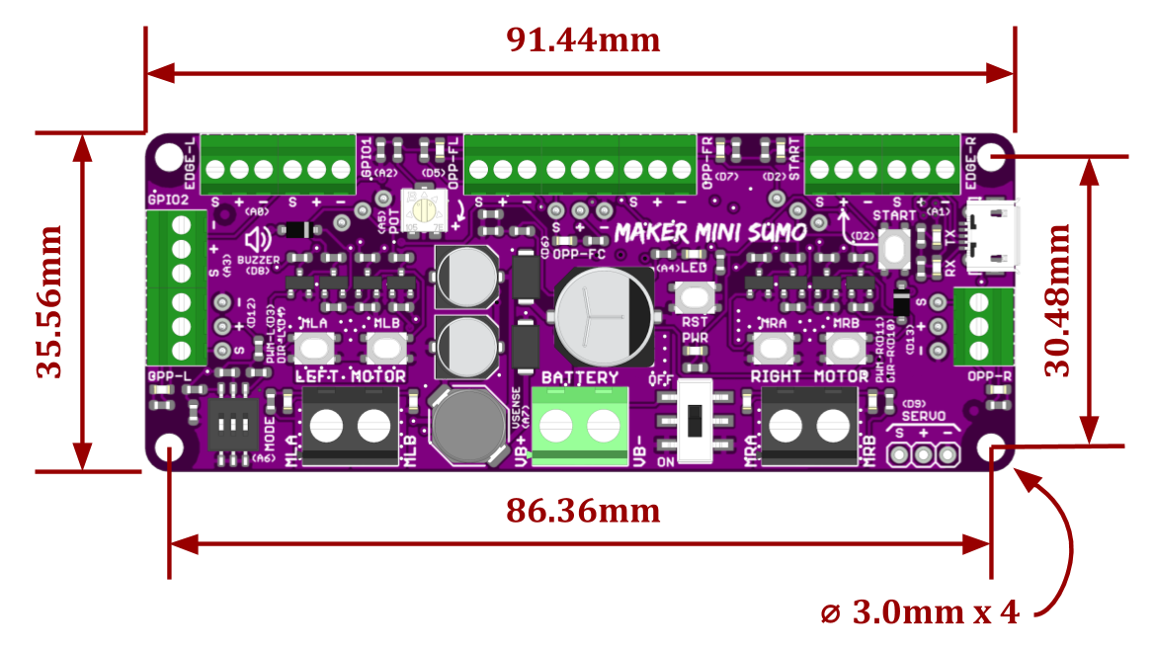

*Figure 3: RCU 7A 2CH Board Dimension*

*Prepared by:*

***Mycest Solutions Sdn Bhd***

[*www.Mycest.com*](http://www.Mycest.com)

No. 3 Tingkat Atas,

Taman Bunga Chempaka Serom 6,

84400 Sungai Mati,

Johor, Malaysia.

*Tel: +6019 – 607 6807*

*Fax: +606 – 975 3630*

*Email:* [*mycestsolution@gmail.com*](mailto:mycestsolution@gmail.com)